**ARTIFICIAL INTELLIGENCE AND ETHICAL CONSIDERATIONS IN ZIMBABWEAN NEWSROOMS: AN EXPLORATORY SURVEY**

**DENHE RERUZIVO CONSULTANCY HUB**

**PROF ADMIRE MARE AND MR ADMIRE MASUKU**

**27 OCTOBER 2024**

**FINAL REPORT**

**Table of Contents**

**EXECUTIVE SUMMARY** 3

**A SUMMARY OF KEY LEARNINGS AND TAKEAWAYS** 5

**INTRODUCTION** 8

**SOCIAL CONTEXT OF THE STUDY** 9

**A BRIEF LITERATURE REVIEW** 11

**METHODOLOGY** 13

**KEY FINDINGS** 14

**DEMOGRAPHIC INFORMATION OF PARTICIPANTS** 14

**Figure 1: Gender of research participants** 14

**Figure 2: Age of participants** 15

**Figure 3: Years of experience in journalism** 16

**Figure 4: Kind of news organisations journalists are working for** 17

**Figure 5: Roles and Occupation within the newsroom** 17

**USAGE OF AI TOOLS IN ZIMBABWEAN NEWSROOMS** 17

**Figure 6: Usage of AI in newsrooms** 18

**Figure 8: Safety and security protocols around the use of AI tools** 25

**Perceptions of journalists who submit AI-generated news copy as their own** 25

**Figure 9: Moral justifications around submitting AI-generated copy as personal work** 28

**Figure 10: Availability of anti-plagiarism software in Zimbabwean newsrooms** 28

**Ways to promote the transparent and responsible use of AI in newsrooms** 29

**How to attribute AI-generated stories in the newsroom?** 30

**Intellectual property rights and AI integration in the newsroom** 31

**How can AI developers ensure fair compensation for data collected from news organisations to train their models and systems?** 32

**How do you ensure the authenticity and provenance of AI-generated content?** 34

**Figure 11: Automatic content personalisation and recommendation** 34

**Figure 12: Training opportunities on AI use in the newsroom** 35

**Figure 13: Relevance of training on ethical uses of AI in the newsroom** 36

**Figure 14: Existence of AI ethical guidelines and frameworks in Zimbabwean newsrooms** 37

**Figure 15: Relevance of existing codes of ethics and conduct** 38

**Necessity of government regulation in the design, use and deployment of AI** 39

**Figure 17: Necessity of government regulation around AI use** 39

**RECOMMENDATIONS** 40

**CONCLUSION** 42

**REFERENCES** 44

# 

# **EXECUTIVE SUMMARY**

Like previous technologies, there is a deep-seated acknowledgement that the use of generative artificial intelligence (hereafter GenAI) in journalism has the potential to unlock productivity and innovation but also presents risks and ethical challenges. This double-edged nature of technology means that it has the potential to be used as a force for public good but also public evil. Newsrooms are increasingly using corporate AI tools like Bard, Gemini, Claude, Copilot, Bing and ChatGPT to turbo-charge their news-making practices and cultures. Oftentimes these newsroom uses and deployments are not guided by ethical principles and codes of conduct. Technologists do not just need to make the technology work and scale it up, they must make it work while also being responsible for a host of societal, ethical, legal, and other human-centred concerns in various domains including in journalism. There is consensus amongst scholars and media practitioners that the current codes of ethics fall short in addressing some of the pernicious implications of integrating GenAI in journalism. This is despite the fact that codes of conduct articulate general expectations for responsible practice and facilitate the understanding of issues arising around that practice. Cognisant of the ethical foggy zone caused by the introduction of GenAI in news making practices, this timely report presents survey and interview data on the ethical implications of the deployment and use of these tools in Zimbabwean newsrooms. Some of the ethical challenges relate to inaccuracies, copyright abuse, concerns around public trust, invasion of privacy, lack of transparency, human oversight and biases.

This report serves as the first deep-dive and exploratory snapshot of how news media in Zimbabwe are grappling with the ethical implications of GenAI. It presents a survey of 17 respondents coupled with 13 key informant interviews with female and male journalists in Zimbabwean newsrooms about how they use generative AI and what they see as the main ethical issues around its deployment and use in the newsroom context. An online survey via Google Forms was conducted from September 10 to October 25, 2024. The link to the survey was circulated via WhatsApp, Facebook, X and emails for increased visibility and wider reach. A total 13 key informant interviews and semi-structured interviews with reporters and editors were conducted between 10 and 25 October 2024. Ethical considerations such as informed consent, privacy and confidentiality were guaranteed to all respondents. Thematic analysis was used to analyse the findings from interviews and key informant interviews.

# **A SUMMARY OF KEY LEARNINGS AND TAKEAWAYS**

Based on participants’ responses and our analysis, it is clear that GenAI is already being used in the news production cycle by journalists in Zimbabwe, although there is a concerning absence of ethical guidelines and frameworks. The absence of ethical guidelines and frameworks has not stopped journalists from experimenting with text-to-audio, audio-to-text, video, translation, grammar and transcription AI tools. Some of the key takeaways from this study are captured below:

* **Integration of GenAI in newsrooms**. Journalists are increasingly using AI tools in their day-to-day duties. The study also revealed that some journalists, as reflected in previous studies[1] use AI tools involuntarily (76.5%) while others (17.6%) do not use AI tools in their work. This shows that the majority of surveyed journalists are using Gen AI tools in their day-to-day news making practices. Only 5,9% of the surveyed journalists were uncertain about whether they were using GenAI or not. Most respondents indicated that there was no official position on how the tools were supposed to be deployed.
* **Types of GenAI tools in use**. The majority of the respondents (70.6%) use text-based generative AI tools in their line of duty, followed by text-to-audio (11.8%). At least 5,9% of the respondents used transcription GenAI tools like Otter and Whisper. 5.9% used in-house tools while 5.9% deployed other AI tools on the market. The results confirm studies from across the globe that journalists use AI tools for complementary purposes to improve speed and efficiency.
* **Varied understandings of AI in newsrooms**. Respondents had varied understandings of what constitutes artificial intelligence (AI). Some saw it as a tool that they could use to amplify their “…skills as reporters and fast-track some lines of work in our field”. Others used it for research, fact-checking, transcription, translation and summarisation of long texts.
* **Concerns about misuse of GenAI**. Other respondents felt that AI was promoting laziness among journalists. This concern was raised because tools like ChatGPT, Dall-e, Copilot, Bard and Bing allow journalists to input queries like writing summaries, intros/ leads, summarisation, research, fact-checking and translation. Still, others noted that it was still early days to pass the verdict on its strengths and weaknesses.
* **Ethical Concerns and Responsibility**: With regards to ethical challenges journalists faced by journalists in using AI in newsrooms, a mixed bag of results was found. Some of the participants felt that newsrooms in Zimbabwe not investing in acquiring the latest AI tools and systems.Others felt that AI was not “authentic” or “original” because it is “artificial”. Its “artificialness” makes it prone to abuse, inaccuracies, biases and hallucinations. Participants also talked about rising cases of plagiarism, copyright violations and blatant disregard for intellectual property rights in the AI age.
* **Safety and Security Protocols**. In terms of safety protocols that newsrooms have affected in their interaction with AI tools, the study found that the majority of respondents said they did not put any measures while some are experimenting with data encryption, and anti-plagiarism checks while others said they were not aware of any measures. Generally, indications are that newsrooms are ill-prepared for security breaches associated with the deployment and use of AI tools.
* **Undeclared use of AI in news writing**. The majority of respondents felt that using copy that has been produced by AI without acknowledging the source constitutes unethical journalistic conduct. The situation is made worse by the fact that most newsrooms in Zimbabwe have no AI ethical guidelines and frameworks. They rely on the traditional code of ethics and conduct enforced by the Voluntary Media Council of Zimbabwe.
* **Strategies for Responsible Use**. Respondents proposed many interventions to address ethical infractions associated with using AI tools in news production processes. The propositions ranged from radical stances, and capacity-building interventions to setting up journalistic guidelines on using AI. Overall, respondents felt that more training should be done to capacitate journalists and newsrooms should come up with AI guidelines for journalists. Journalists feel that training workshops on AI should focus more on humanising these tools, promoting safety and security and safeguarding law and copyrights.
* **Attribution of AI-generated articles**. Another question that the study sought to address was how journalists attributed AI-generated stories. Responses showed that there was still resistance among editors to publish AI-generated stories and failure to attribute at all. Due to a lack of clear guidelines, some journalists are resorting to using the tools without the knowledge of their superiors.
* **Need for revising codes of ethics and conduct for media practitioners**. The current regime of code of ethics governing media in Zimbabwe is increasingly becoming outdated. There is an urgent need to review the code of ethics in tandem with changes in the media ecosystem turbo-charged by the introduction of AI, algorithms and robotics.

# **INTRODUCTION**

This exploratory study deploys a mixed methods approach to unpack the ethical implications of using mostly artificial intelligence[2] (AI) tools in Zimbabwean newsrooms. For data collection, the report relied on key informant interviews, semi-structured interviews and an online survey (Google Docs administered). While the deployment and use of generative AI[3] (GenAI, hereafter) is still at a very nascent stage in African newsrooms, there is anecdotal and empirical evidence which shows that journalists and newsrooms are using these tools throughout the news production cycle. Most of the strategic actors within the news-making business rely on corporate third-party tools like ChatGPT, Bard, Dall-E, Copilot, Bing and so forth. Others are using AI tools embedded in digital platforms such as Google, Facebook, X (formerly Twitter), WhatsApp, Chart Beat and TikTok. Still, there are exceptions whereby media start-ups like CITE based in Bulawayo have designed and deployed their news anchor, *Alice*. Evidently, there is emerging empirical evidence that shows that newsrooms in Africa are exhibiting growing interest in using GenAI for news production processes. Cognisant of the risks and threats associated with AI tools and models, there are growing calls for designers of AI tools to consider social, cultural and economic factors when configuring these potentially disruptive technologies. Studies highlight that there are also growing calls for the design and deployment of responsible AI tools in newsrooms. Because AI is still a buzzword bandied about in policy and public circles, very little has been done to explore the ethical implications of deploying these tools in African newsrooms including in Zimbabwe. Unfortunately, while newsrooms in the Global North have taken steps to design AI ethical guidelines and principles for journalists to inform the use and appropriation of AI, little is known about what newsrooms in Africa and Zimbabwe particularly are doing in that respect. This study sought to fill that gap.

Despite the convenience, efficiency and speed with which AI tools execute journalism work-related tasks, many concerns have emerged including their deployment in the production and distribution of disinformation, copyright violations, lack of transparency, limited human intervention in the loop, inaccuracies, biases and lack of attribution for AI-assisted stories. Reporters and editors in Zimbabwe are increasingly using AI tools for complimentary tasks such as text, audio, and video editing and translation, data analytics, and fact-checking news. In some Zimbabwean newsrooms, despite the acknowledgement that AI is transforming journalism production cultures, there are no in-house ethical guidelines and principles on how to integrate these tools ethically and responsibly. In the end, most journalists are deploying and using these tools without any set of ethical guardrails. This ethical vacuum exposes journalists and news consumers to several risks and threats.

# **SOCIAL CONTEXT OF THE STUDY**

There is consensus among scholars[4] that most newsrooms in Zimbabwe have been slow to embrace interactive digital technologies due to various reasons related to connectivity challenges and the nagging issue of the digital divide. The situation was made worse by the “Zimbabwean crisis”[5], which amongst other issues led to massive capital flight, a general neglect of the telecommunications infrastructure and an under-investment in the media sector. This state of affairs changed in 2009 following the signing of the Global Political Agreement (GPA) between bitter rivals Robert Mugabe (ZANU-PF) and Morgan Tsvangirai (MDC-T). With the birth of an inclusive government, hyper-inflation was arrested, and a semblance of normalcy and predictability was restored[6]. The introduction of the multi-currency system as well as the dollarization of the economy led to significant investments in the telecommunications sector. It led to the roll of 3G technology in August 2009, which positively impacted the internet and social media penetration rates.

According to DataReportal (2024), Zimbabwe’s internet penetration rate stands at 43.5%. This indicates that at least half of the population is not online and, therefore, is excluded from the enjoyment of the affordances of mainstream and emerging technologies (such as AI tools). The advent of digital technologies has enabled media organisations to leverage these tools for news production, distribution, consumption and engagement. Whilst digitization has brought positives to the media industry, it has also exposed the industry to several sustainability and trust-related challenges. Advertising competition spent with Big Tech has accentuated media sustainability challenges with some news publishers closing shop. Journalists have been exposed to online harassment and hate speech on social media platforms. Other media houses have been criticised for peddling disinformation and misinformation online. This has contributed to a decline in media trust across the board. These challenges have also affected the Zimbabwean media, especially the legacy platforms (like newspapers, radio, magazines and television).

Digitisation-related opportunities and risks have accentuated the precarious operations of the media in Zimbabwe, which are already characterised by high staff turnover rates, juniorisation of newsrooms, incapacitation of workers, critical AI skills shortage and lack of quality digital and human infrastructure. This is so, even though some organisations including the MISA Zimbabwe are conducting periodic training programmes on AI and newsroom cultures. In terms of AI preparedness, Southern Africa has the lowest average score in the world Oxford Government AI readiness index[7] (2023). This demonstrates serious challenges to government AI adoption in the region[8]. Mauritius, South Africa, Rwanda, Senegal and Benin are among the top 5 countries with the highest AI preparedness score[9]. In other industries, some African countries (South Africa, Kenya, Mauritius, Ghana, and Egypt) have even gone beyond the experimental stages and developed AI strategies to guide adoption, use, and implementation strategies[10]. Zimbabwe is yet to launch its national strategy even though there are media reports that the government is planning to do so[11]. This chimes with research that shows that the deployment of AI technologies is proliferating on the African continent, but policy responses are still in their early stages[12]. According to SprutSolutions (2024), there are over 2,400 AI companies in Africa that have been set up over the last few years. This points to the fact that AI adoption is gaining momentum and increasingly impacting industries in the continent. However, very little is known about how newsrooms are deploying and using AI tools for news production processes. Several reasons have been given for the slow adoption of AI in Africa in general and Zimbabwe in particular. Scholars[13] have identified Africa’s cosmopolitan culture including diverse languages as a major hindrance. According to the International Telecommunication Union (ITU) (2024) of the top 34 languages used on the internet globally, not one single one is African. Some of the challenges facing AI adoption include a notable gap in knowledge about AI, resource constraints, fear of the negative impact of algorithmic systems and professional precarity among journalists, cultural resistance within newsrooms, marginalisation of women in the newsroom, weak policy and legal infrastructure, lack of appropriate AI business strategies, the existence of ‘dirty’ data, and a lack of collaboration among news actors in the continent[14].

# **A BRIEF LITERATURE REVIEW**

In Africa, studies[15] on AI and mainstream journalism are still at a nascent stage. The studies indicate that AI deployment for newsroom processes is still in the embryonic stages compared to other sectors. In other sectors, there have been breakthroughs, especially in the health sector, banking, fintech, education, and agriculture[16]. AI use and deployment for news work is still in its infancy[17]. Extant research shows that AI in newsrooms is used for a range of tasks, such as transcribing interviews, to more complex functions, like detecting fake videos and images[18]. Even though some media startups such as the Centre for Innovation and Technology (CITE) are experimenting with automated journalism cultures. Literature shows that while there is AI use and deployment across several news organisations in Africa, the level and breadth of adoption remain relatively low[19]. AI use and deployment also vary regionally and across different media, with the most use cases in Kenya and South Africa[20]. The big well-resourced media have invested in several premium AI systems and are also developing several custom-built AI tools[21]. However, most of the smaller media organisations have either not integrated AI tools into their newsroom processes, or where they have done so, they rely largely on open-source tools. The most used AI systems are functional AI, deployed in content/news gathering, content processing, content/news distribution and audience engagement, and various editorial practices[22].

An earlier study conducted before the launch of ChatGPT in November 2022 revealed a slow, varied but methodical uptake of AI practices in South Africa’s mainstream newsrooms[23]. This study also revealed that there is a holistic appropriation of AI in South African newsrooms. It also identified what it called the “exclusively technological appropriation of AI”[24]. Then, there is the ‘task-specific appropriation of AI’. Interestingly, the study found that the varied uptake of AI is taking place against a deep-seated skepticism about this technology[25]. The skepticism is driven by fear of job losses, the costs of adopting AI, limited training, and ethical issues around AI and its efficacy in the democratic process. There is a need for more research focusing on the ethical implications of appropriating AI tools for news production processes. It can be argued that the state of AI adoption in Africa is not evenly distributed but is aligned with the state of technological infrastructure, data and AI-conversant human infrastructure. Building on earlier studies, this study sought to examine the ethical dimensions of AI use and deployment in newsrooms, an issue which has often been overlooked.

# **METHODOLOGY**

This exploratory study relied on a mixed methods approach to collect data on the ethical implications of integrating AI tools in newsrooms. The researchers administered an online Google Docs survey targeting full-time and freelance journalists working in major newsrooms in Zimbabwe. The link was shared via emails, WhatsApp and X for wider reach. At the time of writing the final report, 17 participants had responded to the online survey. The data that were collected through the survey was complemented by follow-up interviews with journalists in major newsrooms in Zimbabwe. It relied on a sample of media practitioners drawn from full-time, part-time, contract, and freelance journalists who were selected through purposive sampling. Freelance journalists were accessed at the Media Centre and other co-working spaces in Harare.

To complement data gathered through the survey instrument, the consultants conducted 13 follow-up key informant interviews with purposively selected respondents. These interviews were conducted in person and via WhatsApp. Some of our WhatsApp interviewees were based in Harare, Bulawayo, Masvingo, Gweru, Mutare and Chinhoyi. On average, each key informant interview lasted for 30 minutes. We ensured gender balance and regional diversity in our recruitment of respondents**.** The interviews explored questions about ethical challenges associated with the deployment of AI tools in Zimbabwean newsrooms and the AI cultures in newsrooms. Ethical considerations such as informed consent, privacy and confidentiality were guaranteed to all respondents. In some cases, pseudonyms were used to protect the identities of our interviews. In other cases, real names were used. This is because some journalists gave us permission to use their real names while others were not comfortable to do so. Thematic analysis was used to analyse the findings from interviews and key informant interviews.

# **KEY FINDINGS**

## **DEMOGRAPHIC INFORMATION OF PARTICIPANTS**

Before articulating the main findings of the study, there is a need to reflect on the demographic information of the participants. The report deals with the gender, age, journalistic beats, experience, and geographical location (provinces) of participants.

In terms of gender, more male journalists responded to the survey (70.6%) with females accounting for 29.4%. This further supports the idea that journalism is predominantly dominated by males. Females often struggle to survive the deadline-oriented nature of the industry.

### **Figure 1: Gender of research participants**

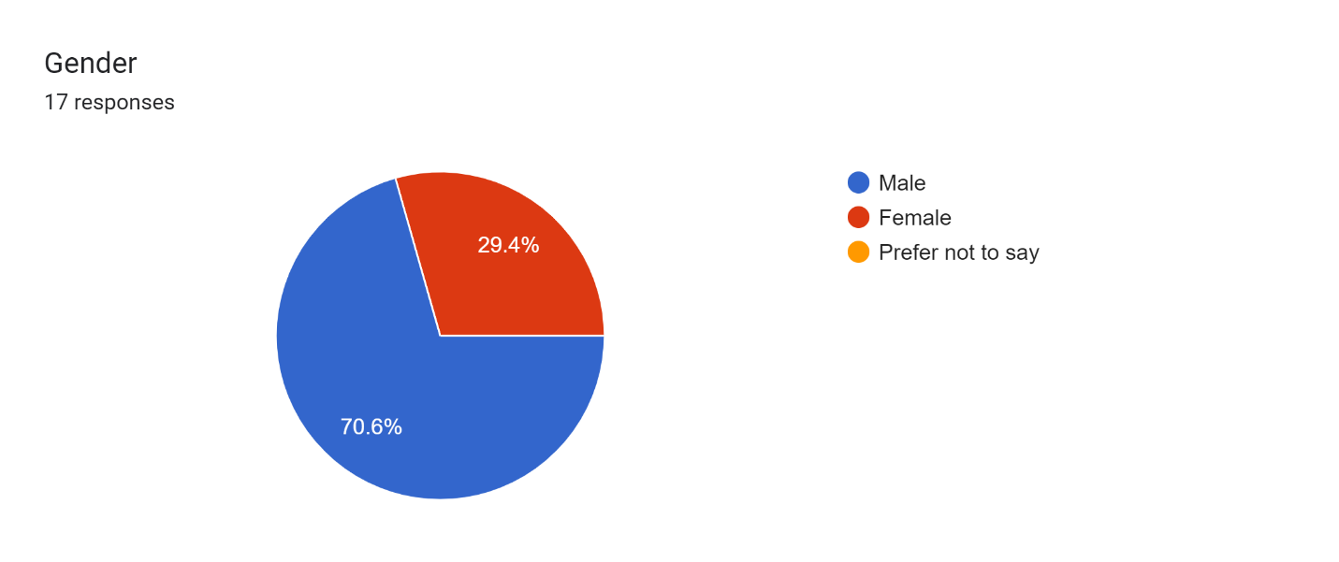

As far journalistic beats are concerned, most of the survey respondents were from politics followed by sports and entertainment reporters.

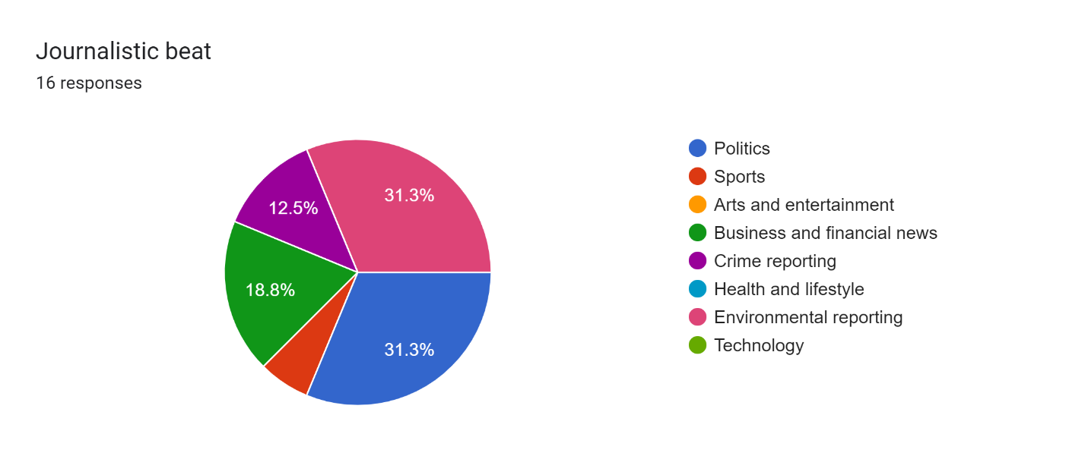

In terms of age group, the study targeted people between the ages of 18 and 55 with the majority of respondents being in the 26-35 (47.1%) category, followed by the 36-45 age group (35.3%), 46-55 age group (11.8%) and lastly 18-25 years age group at 5.8%.

### **Figure 2: Age of participants**

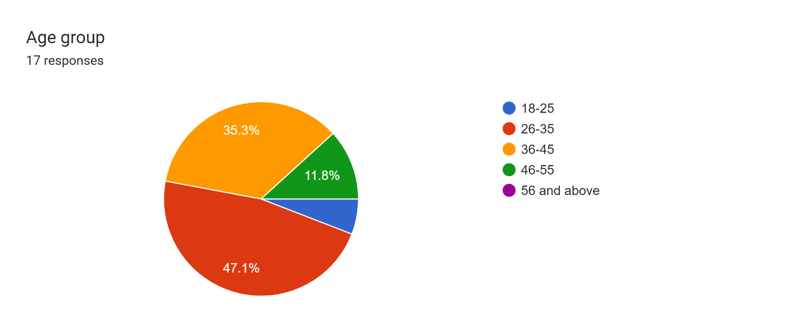

In terms of provinces, the majority of participants were in Harare (70.6%), followed by Mashonaland (23.5%) and Masvingo (5.9%).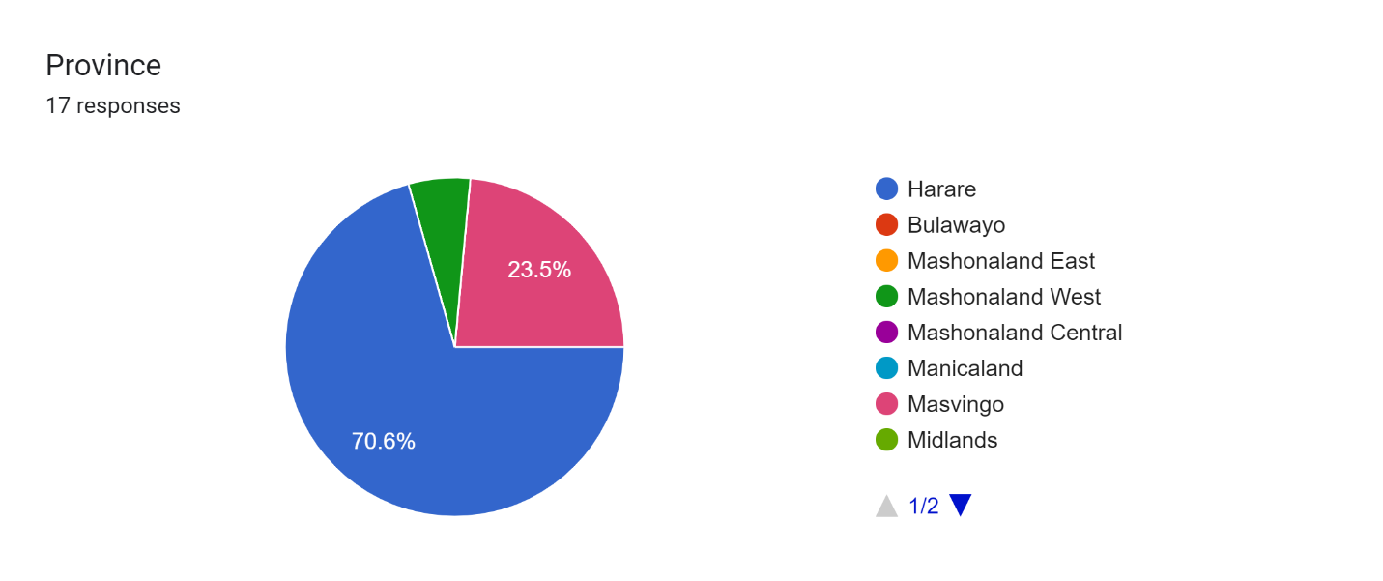

### **Figure 3: Years of experience in journalism**

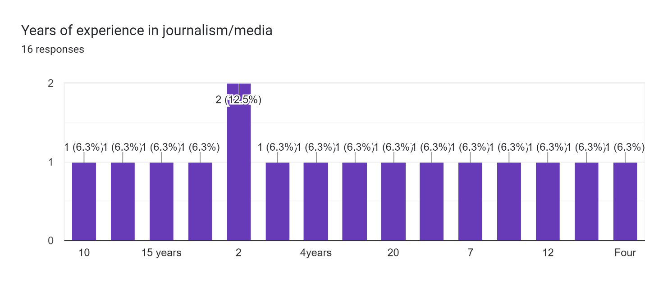

The majority of the respondents for this study came from journalists working for newspapers (41.2%), followed by online media (17.6%), other (17.6%), and radio (11.8%). The other journalists were working for magazines (5.9%), and television (5.9%)

## **Figure 4: Kind of news organisations journalists are working for**

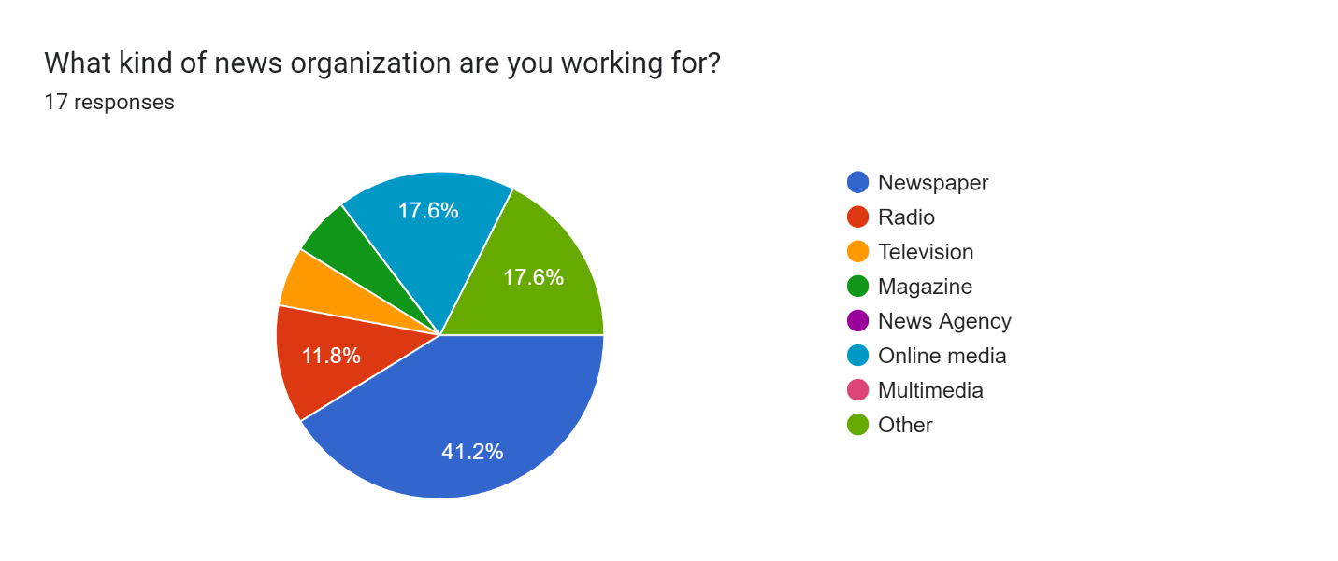

In terms of roles and occupation, the majority of respondents were journalists (52.9%), followed by editors (23.5%), reporters (17.6% and lastly moderators (6%).

### **Figure 5: Roles and Occupation within the newsroom**

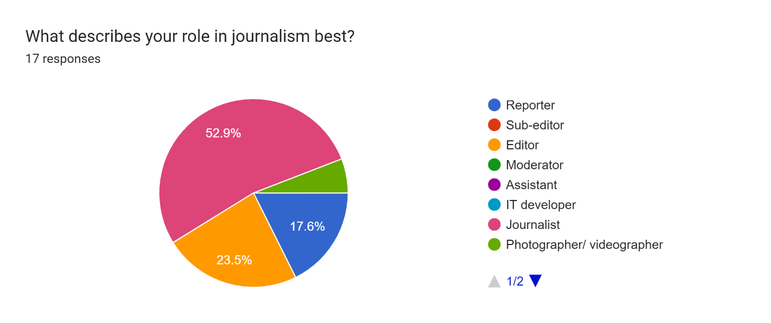

# **USAGE OF AI TOOLS IN ZIMBABWEAN NEWSROOMS**

Findings from the online survey corroborate empirical research that journalists are increasingly using AI tools in their day-to-day duties. The study also revealed that some journalists, as reflected in previous studies[26] use AI tools involuntarily while others do not use AI tools in their work. Data collected reflect an understanding of Generative AI tools and how AI compliments journalistic duties while improving the efficiency and speed with which news products are distributed.

### **Figure 6: Usage of AI in newsrooms**

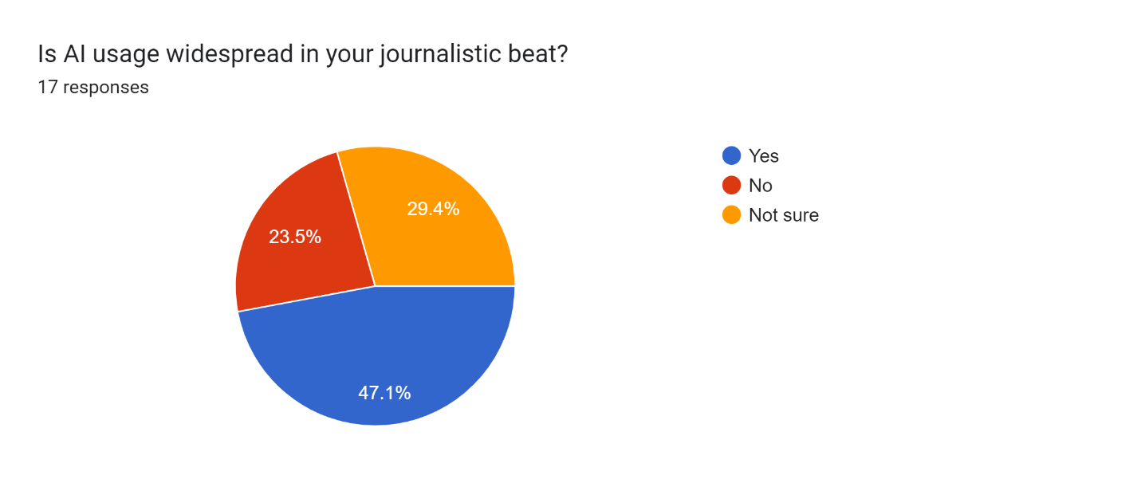

One of the questions in the online survey sought to understand how widespread the use of AI in beat reporting with the majority of respondents (47.1%) indicating that this is a common practice. Of the total respondents 23.5% indicated that they do not use AI tools while 29.4% were unsure.

The majority of the respondents (70.6%) use text-based generative AI tools in their line of duty, followed by text-to-audio (11.8%). The results cement earlier findings that journalists use AI tools for complimentary[27].

**Figure 7: Types of AI tools used in Zimbabwean newsrooms**

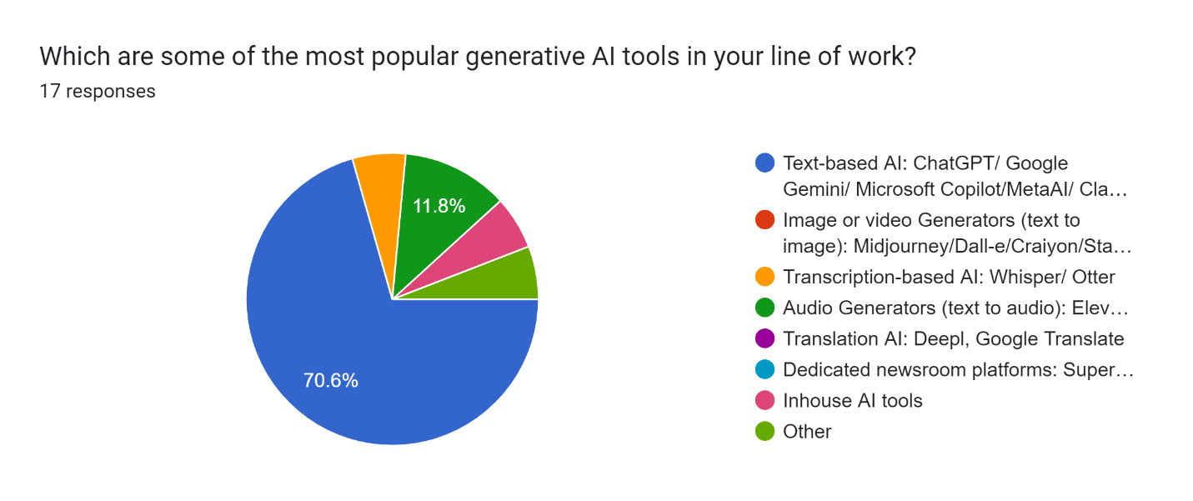

When respondents were asked what they understood by the term artificial intelligence (AI), responses varied between what AI can do and what AI is. One of the respondents said a tool that amplifies “our skills as reporters and fast-track some lines of work in our field.” Another respondent described it as a tool that “makes the “job easy for lazy people”. While others said AI has enhanced technological intelligence. This limited understanding of AI is not unique to Zimbabwean journalists. Studies in East and Southern African newsrooms have also revealed that journalists have a limited understanding of AI. Those who were closer to understanding AI said:

* “These are computer systems that can perform tasks that usually require human intelligence.”
* “The simulation of human intelligence in machines that are designed to think, learn, and solve problems like humans”.
* “It is a set of technologies that can simulate human intelligence”.
* “Modern-day applications that foster ease of doing research but on the other hand promote and create”.

On the question that sought to understand how journalists were deploying AI in their line of work, the response showed that the tools were used mainly for complimentary purposes that improve speed and efficiency. The online responses were as follows:

#### **Table 1: Responses on how journalists are using AI tools**

|  |  |
| --- | --- |
| **Respondent(s)** | **Responses** |
| Online respondent 1 | Transcription of audio to text. 2. Summarising long texts 3. Picking important facts in a long transaction or text. |
| Online respondent 2 | Transcribing, editing, proofreading |
| Online respondent 3 | It has made it better |
| Online respondent 4 | To correct grammatical errors. |
| Online respondent 5 | Fact-checking |
| Online respondent 6 | Used for correcting grammar, content creation (graphic designing, transcribing) and for data visualisation. |
| Online respondent 7 | AI is being used for research purposes, perfecting grammar, paraphrasing other people's works, and angling of stories, also used to improve conciseness and clarity in writing among other things. |
| Online respondent 8 | Research, breaking down and interpreting large data sets. |

Source: Authors

It is evident from the above that Zimbabwean journalists are using GenAI tools for a wide range of purposes. These include research, translation, transcription, summarising long text, fact-checking and data visualisation. Some newsrooms have gone to the extent of developing AI editorial policies, but there is still resistance among reporters who are afraid that the technologies can render them jobless. This is aptly captured below by one of the senior editors:

It's still at entry level. Not much use of AI in writing of stories. For us, we have embraced AI. We have, an AI editorial policy. We are trying to encourage our editors to use more AI, but there are concerns people feel for their jobs and so on and so forth. So, I will say it is still at entry level. People are still trying to figure out. Is it good for us? Is it bad for us? But we think it is good for us. It’s just a tool that you use to do your work. So maybe in the coming years, there’ll be more use of AI (*Interview with William Chikoto, November 2024).*

Other respondents felt that AI was promoting laziness among journalists. This concern was raised because AI tools like ChatGPT, Copilot, Bard and Bing allow journalists to input queries like writing summaries, intros/ leads, research, fact-checking and translation. Still, others noted that it was still early days to pass the verdict on its strengths and weaknesses. This was captured as follows by one of the online respondents:

“So far, I'm personally still coming to terms with and navigating what AI entails, I am aware that quite a cross-section of journalists carries out their research using AI or even let it generate texts while they are sitting on their laurels.”

Some of the respondents felt that AI has improved the work of professionals who are in charge of quality control in the newsrooms. One of the online respondents to the survey said:

“It is used to help professionals to become more efficient in writing stories, summarising documents, editing, creating images and in language translation.”

Despite the potential of AI tools to improve the efficiency of journalistic work, data from key informant interviews show that it is associated with a plethora of ethical challenges. These challenges as captured below:

AI tools have immense potential to enhance productivity and accuracy, especially in journalism, but they also introduce a series of ethical dilemmas. In my experience at the Centre for Innovation and Technology (CITE), one of the main ethical dilemmas I've encountered relates to the balance between automation and human judgment. For example, with tools like Alice, our AI news anchor, there’s a temptation to prioritise speed and cost-efficiency over human editorial oversight. However, this raises concerns about the accuracy, nuance, and contextual understanding that AI sometimes lacks. Additionally, content generation or distribution tools may inadvertently amplify biases or misinformation and erode public trust. Another ethical issue is transparency. AI tools can operate as "black boxes," where it's not always clear how certain conclusions or outputs are reached. This makes it difficult to maintain accountability in the newsroom *(Interview with Sean Ndlovu, CITE in Bulawayo, October 2024).*

Asked what ethical challenges journalists faced by journalists in using AI in newsrooms, a mixed bag of results was found. For instance, others had this to say:

Some of the dilemmas include concerns around authenticity, transparency and accountability. For example, there's a risk that AI-generated content might be mistaken for human journalism, leading to questions about the credibility of sources(*Interview with Lovejoy Mtongwiza, Harare, October 2024*).

Respondents felt that newsrooms in Zimbabwe not investing in acquiring the latest AI tools.Others felt that AI was not “authentic” or “original” because it is “artificial”.

Reporters are increasingly relying on AI to generate stories, but this comes with its pitfalls, especially insofar as crediting the stories is concerned. In most instances, reporters attach their bylines. This is not only dishonest but unethical as readers have the right to know the source of the material they consume. This also applies to the generation of various other illustrations – cartoons, graphics, etcetera. … The dilemma also comes with properly attributing the generated material. Issues such as copyright and intellectual property, therefore, come into play *(Interview with Darlington Musarurwa Harare, October 2024).*

Some of the dilemmas include concerns around authenticity, transparency and accountability. For example, there's a risk that AI-generated content might be mistaken for human journalism, leading to questions about the credibility of sources(*Interview with AMH Digital and Online editor, Silence Muchemwa Mugadzaweta Harare, October 20*24).

Interviewees pointed out that its “artificialness” makes it prone to abuse, inaccuracies, biases and hallucinations. Some respondents observed that one of the challenges with using AI is copyright issues. They argued that it was difficult to:

Ensure transparency and accountability in AI-generated content. For instance, when using AI-powered writing assistants, one would have to consider whether to disclose that AI was involved in the content creation process. This raises questions about authorship, bias, and potential misinformation(*Interview with a male journalist based in Harare, October 2024*).

Participants also highlighted rising cases of plagiarism, copyright violations and blatant disregard for intellectual property rights in the AI age. Interviews conducted revealed that apart from inherent biases, AI tools amplified information disorders through hallucinations.

AI tools used for content generation or distribution may inadvertently amplify biases, and misinformation and erode public trust. Another ethical issue is transparency. AI tools can operate as "black boxes," where it's not always clear how certain conclusions or outputs are reached. This makes it difficult to maintain accountability in the newsroom. Given AI's potential to reshape how news is created and consumed, we must remain vigilant about how much autonomy we grant these systems. (*Interview with Sean Ndlovu, CITE Bulawayo, October 2024*).

I have not personally used AI tools that much, but the major ethical concern of AI is the potential for creating and spreading misinformation and fake news.(*Interview with Ishmael Ndlovu, Harare, October 2024*).

The general sentiments of most participants are captured in the following quotes:

“AI tools largely rely on large amounts of personal data raising privacy concerns. AI tools can be vulnerable to security breaches.” (online respondent 1).

“Newsrooms do not invest in AI tools and the latest technological equipment (online respondent, 4).

“Copyright infringements as some responses will be based on historical articles /plagiarism” (online respondent 6).

“Overreliance on AI leads to a decline in original reporting and investigative journalism. production of fake news through hallucinations of some of the AI platforms or apps” (online respondent 7).

“AI algorithms often rely on large datasets to generate content or assist with fact-checking, but these datasets can contain biases. The dilemma of how to maintain a balance between leveraging AI's capabilities while ensuring the preservation of investigative rigour and creativity” (online respondent 8).

While journalists are conscious of the inherent biases in AI tools in news production processes, they feel that it is not always possible to verify information due to journalistic pressures. One of our respondents explained it as follows:

One has to be sure that what AI has produced is factual, but because AI serves to take pressure away from journalists and allows one to meet deadlines. It becomes a challenge to consistently double-check*.* (*Interview with Monica Cheru, Harare, October 2024*).

In terms of safety protocols that newsrooms have affected in their interaction with AI tools, the study found that the majority of respondents said they didn’t put any measures while some are experimenting with data encryption, and anti-plagiarism checks while others said they were not aware of any measures. Generally, indications are that newsrooms are ill-prepared for security breaches associated with the deployment and use of AI tools.

### **Figure 8: Safety and security protocols around the use of AI tools**

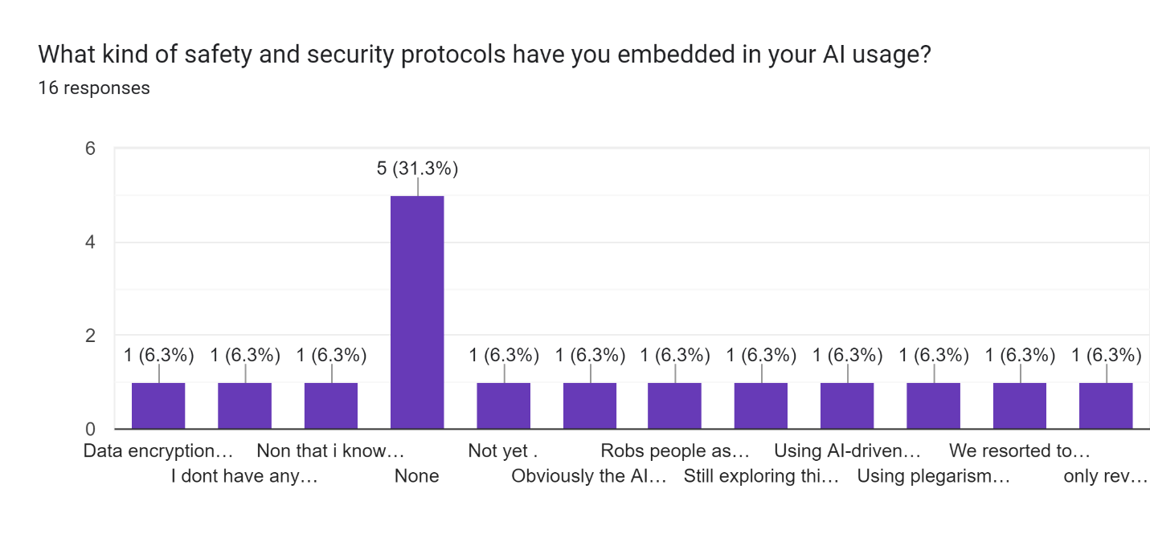

# **Perceptions of journalists who submit AI-generated news copy as their own**

Respondents felt that the use of AI for news production processes borders on unethical practices and copyright infringement. The online respondents had this to say:

* “This is very wrong. Besides it can be easily detected as AI tools remove the emotional and originality of the news copy” (online respondent 8).
* “They're supposed to be sued” (online respondent 14)
* “I feel like it's unethical. I believe AI should aid to correct grammar and be used as a fact-checking tool. Using it to write a whole story is bad” (online respondent 11).
* “They will end up spreading misinformation” (online respondent 10).
* “The stories lose the human story effect. While some were concerned about unethical practices associated with AI, they said it is easy to detect AI-generated stories from human-generated stories” (online respondent 12).

“The articles usually lack originality therefore it harms the reputation of journalism” (online respondent 7).

This is a problem that is continuing unabated. I interact with AI and can easily tell an AI-generated news copy. They are flooding the press these days and I believe it is killing the industry. overreliance on these tools creates lazy journalists who cannot recall what they would have written in their copies and defend their lines of argument because essentially the copy will not be theirs.” (online respondent 9).

Linked to the question on ethics, the majority of respondents (93.8%) felt that using copy produced by AI without acknowledging the source constitutes unethical journalistic conduct (see the infographic below). 6.3% of the respondents felt that it was justified to use GenAI to write stories. The situation is made worse by the fact that most newsrooms in Zimbabwe have no AI ethical guidelines and frameworks. They rely on the traditional code of ethics and conduct enforced by the Voluntary Media Council of Zimbabwe. Data gathered through key informant interviews indicate that the code of ethics is anachronistic and needs to be revised to match developments in the news ecology. Below are their responses:

Zimbabwe's current media code of conduct could be revised to include explicit guidelines for AI usage in journalism. First, AI-driven content creation and curation must prioritise transparency, ensuring that AI's role in generating news is disclosed to the audience. Ethical guidelines should also emphasise mitigating algorithmic biases by promoting diversity in AI training datasets to reflect Zimbabwe’s unique cultural and societal context. (*Interview with Sean Ndlovu, CITE, October 2024*).

The code of conduct should include guidelines on the responsible use of AI, emphasizing transparency about when AI tools are used to generate content. Journalists should disclose if an AI system has contributed to any part of a report. The code should also address the importance of verifying AI-generated. (*Interview with Lovejoy Mtongwiza, October 2024*).

There is a need for a clear code of conduct that properly credits stories, as well as coming up with guidelines on the minimum amount of AI-generated material that can be inputted into a story for it to be regarded as an original article for the reporter and media house.(*Interview with Darlington Musarurwa, October 2024*)

I think existing journalistic principles are mostly adequate to maintain ethical standards. I think the challenge is with visuals generated by AI and there is a need for full disclosure.(*Interview with Monica Cheru, October 2024*).

Training programmes for journalists on the ethical use of AI should also be mandatory, helping media practitioners understand both the opportunities and risks of these technologies (*Interview with Sean Ndlovu CITE, October 2024*).

### **Figure 9: Moral justifications around submitting AI-generated copy as personal work**

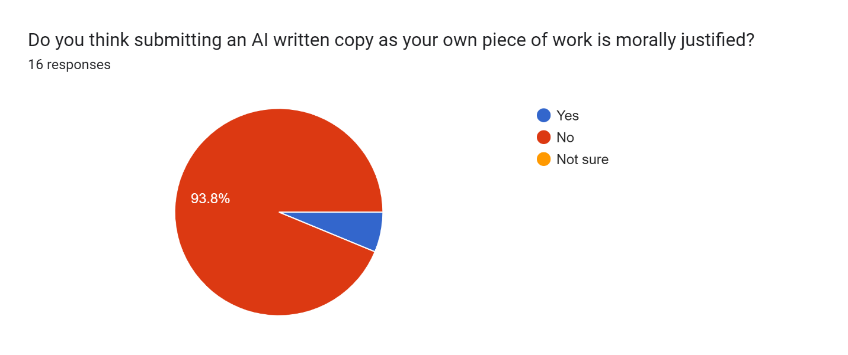

Previous studies[28] show that newsrooms do not have guidelines that guide journalists to use AI tools responsibly. This study also confirms the previous findings including the fact that the majority of newsrooms do not use anti-plagiarism software for quality control.

### **Figure 10: Availability of anti-plagiarism software in Zimbabwean newsrooms**

Forms response chart. Question title: Does your newsroom have an anti-plagiarism software to check AI generated news copies?
. Number of responses: 16 responses.

# **Ways to promote the transparent and responsible use of AI in newsrooms**

Respondents proposed many interventions to address ethical infractions associated with using AI tools in news production processes. The propositions ranged from radical stances, and capacity-building interventions to setting up journalistic guidelines on using AI. Some of the recommendations are captured as follows:

Content verification mechanisms must be integrated into the workflow. AI plagiarism detectors, combined with human oversight, can ensure that AI-generated content does not replicate or excessively mimic existing works without proper attribution. Regular editorial reviews and checks should also be in place to flag AI-generated content that may not meet ethical journalism standards. Newsrooms can also adopt blockchain-based tools for content authentication, ensuring that news pieces are traceable to their sources(*Interview with Sean Ndlovu CITE, October 2024*).

AI tools can pick up stuff from the user and produce content accordingly. So African media practitioners can only change that by constantly feeding the AI tools with their nuances. So instead of complaining and expecting someone else to do something, let’s just get busy and train the tools to reflect our realities(*Interview with Monica Cheru, October 2024*).

There is a need for regular audits of AI outputs: Monitor AI-generated content for biases and errors. Newsrooms can also implement human oversight and editing to detect and correct biases, collaborate with various experts(*Interview with, Valeria Mhandu, October 2024*).

Newsrooms should implement stringent fact-checking and plagiarism-detection systems that can spot AI-generated content that mimics or replicates other sources. Additionally, journalists should be trained to understand the limitations of AI tools and avoid over-reliance on them for content creation(*Interview with Lovejoy Mtongwiza, October 2024*).

Some propositions are listed below: Overall, respondents felt that more training should be done to capacitate journalists and newsrooms should come up with AI guidelines for journalists. Below are their responses:

* Workshops to teach media practitioners how to use AI responsibly.
* Ban it.
* Editors should be capacitated on AI use and have AI policies in the newsroom
* Implementation of house policies against AI.
* Find a tool that detects AI-generated stories.
* Provide training journalists on the capabilities, limitations, and ethical implications of AI.
* Establishing clear guidelines within newsrooms on the ethical use of AI, covering issues like bias, privacy, transparency, and accountability. These guidelines should be communicated to all staff.
* There should be disclosure in the case of AI-generated content as well as attribution to the source.
* Installation of more anti-plagiarism software.
* Develop newsroom policies and guidelines on how to be transparent and responsible.
* Companies should generate AI policies that guide its use in newsrooms.
* There is a need for an AI ethical code for the media.

# **How to attribute AI-generated stories in the newsroom?**

Another question that the study sought to address was how journalists attributed AI-generated stories. Responses showed that there is resistance from editors to publish AI-generated stories and failure to attribute at all. Due to a lack of clear guidelines, some journalists are resorting to using the tools without the knowledge of their superiors. Responses from online respondents are listed below:

* People submit it as their own because there are no tools to check
* It will be regarded as a no-story, it won’t be published.
* Rarely attributed
* Have not experienced that so far.
* Honestly, so far, we haven't reached the stage yet of curbing all such cunning ways and antics on the part of journalists, but very soon the wrath of fair play and diligent work will catch up with not only ours but other newsrooms likewise across the country.
* Acknowledge that the story is AI-generated.
* We usually don’t use stories written by AI.
* It is not openly done, so there is no official position.

We asked respondents how they handled issues of copyright when using AI tools in their newsrooms. The most prominent concern was that most newsrooms have not established protocols to ensure the responsible deployment of AI tools. Most online respondents observed that that they have not yet dealt with any copyright-related ethical dilemmas so far. The online responses were as follows:

* + I have never handled such an issue
  + Verification of facts
  + we do not have comprehensive protocols in place yet.
  + We attribute every foreign-generated copy.
  + We are still lights-out in that regard, for we still need some more schooling about copyrights, patents and intellectual property myopia in the context of AI.
  + Need for attribution
  + This is not something we have a solution to. However, we do not use AI for writing.
  + Spike the stories
  + No experience so far

# **Intellectual property rights and AI integration in the newsroom**

On intellectual property, journalists showed a low understanding of issues around AI and journalism preferring to call them issues of a legal nature. Below are some of their responses:

* Ask legal team.
* I have never seen them identified in the newsroom.
* They are violated because AI may not be accurate.
* Nothing much
* It's difficult to handle most of the issues.
* Yet to figure out since this AI beast has just recently reared its intricate head.
* Yet to engage in such issues.
* We haven’t developed anything around this.

Although the Cyber and Data Protection Act was passed into law in 2021, respondents showed a lack of understanding of the provisions around data protection. Other newsrooms have produced watered-down versions for internal use. This is reflected in the following online responses:

* + I have no idea because editors and management do not do follow-up.
  + Through the use of memorandums.
  + Try to have original stories.
  + Journalists and editors should be versed in the statutes.
  + Adherence to the reference chapter for prescribed conduct is the maiden way like no.
  + I am yet to explore this area.
  + We have come up with a data protection policy which we share with users who share data with us.
  + We haven't taken this into consideration.

# **How can AI developers ensure fair compensation for data collected from news organisations to train their models and systems?**

One of the contentious issues around AI and journalism is the use of media organisation’s data by AI companies without acknowledgement. Around the world, media organisations are tussling with questions on how developers of AI tools should compensate newsrooms for data used in training tools. In Zimbabwe, respondents provided responses that ranged from lack of knowledge around the issues and newsroom-specific compensation policies. These online responses are aptly captured below:

* I don’t know.
* There should be paid packages for AI apps. This should force newsrooms to pay for licenses to use AI information.
* They should create customised AI generators to suit a certain newsroom's policies.
* Automatic deduction when the AI collects any information.
* Since I am using some of these free of charge, I think attribution and acknowledgement will be fair compensation to me.
* AI developers should establish clear, legally binding licensing agreements with news organisations, outlining how their content will be used to train AI models.
* Not yet explored.
* This can be done as a collaborative effort across newsrooms in the country and region to be effective.

When respondents were asked if their newsrooms maintained a public record of AI systems that they use, how they use them, their purposes, scopes and conditions of use, it was apparent theuse of Gen AI tools in the newsrooms is not well documented. While there is public acknowledgement of newsrooms using AI in news production processes, the study shows that these issues are rarely discussed and documented. Some of the online respondents had this to said:

* They don't, I suspect most of our bosses are not well-versed with AI.
* AI systems are being only used to correct grammatical errors.
* No public record is kept.

# **How do you ensure the authenticity and provenance of AI-generated content?**

On how newsrooms ensure the authenticity of AI-generated content, there is evidence that journalists use AI tools while others use a cross-section of tools. Other respondents indicated that there was no official position on how the tools were supposed to be deployed. The online responses gleaned from the dataset were as follows:

* Have tools that identify AI.
* Doing further research on the Ai generated information.
* Fact-checking.
* Verify using Google.
* There is a need to verify the content using multiple sources.
* No clear strategies developed.
* We always cross-reference material
* The company does not have an open AI policy
* Newsrooms should implement stringent fact-checking and plagiarism-detection systems that can spot AI-generated content that mimics or replicates other sources. Additionally, journalists should be trained to understand the limitations of AI tools and avoid over-reliance on them for content creation.

# **Figure 11: Automatic content personalisation and recommendation**

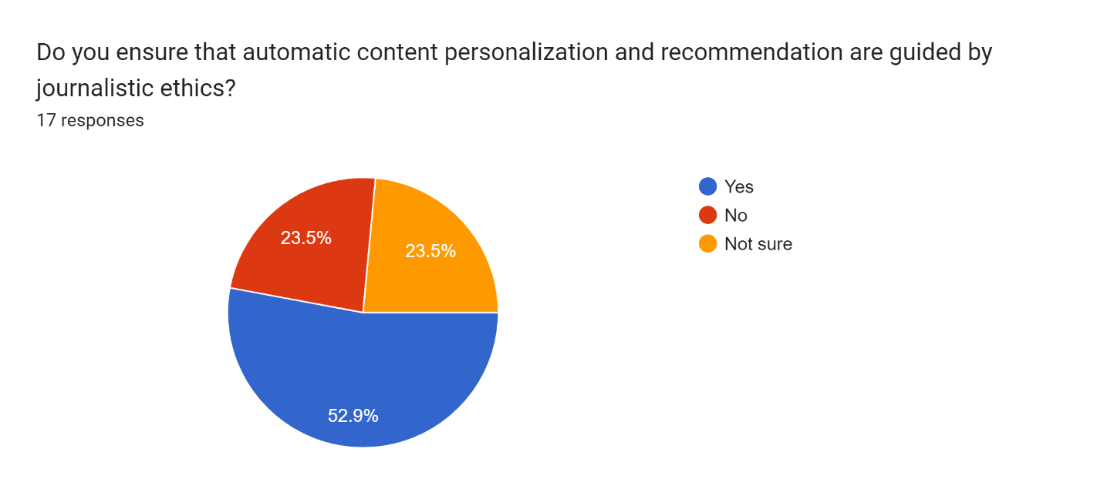

The study also wanted to establish the level of AI understanding among respondents. Despite the low uptake of the tools in the newsroom and superficial understanding of AI and its impact on journalism, a small number of respondents (23.5%) indicated that they had received training (see Figure 12). In contrast, 76,5% said they have not received training on AI.

### **Figure 12: Training opportunities on AI use in the newsroom**

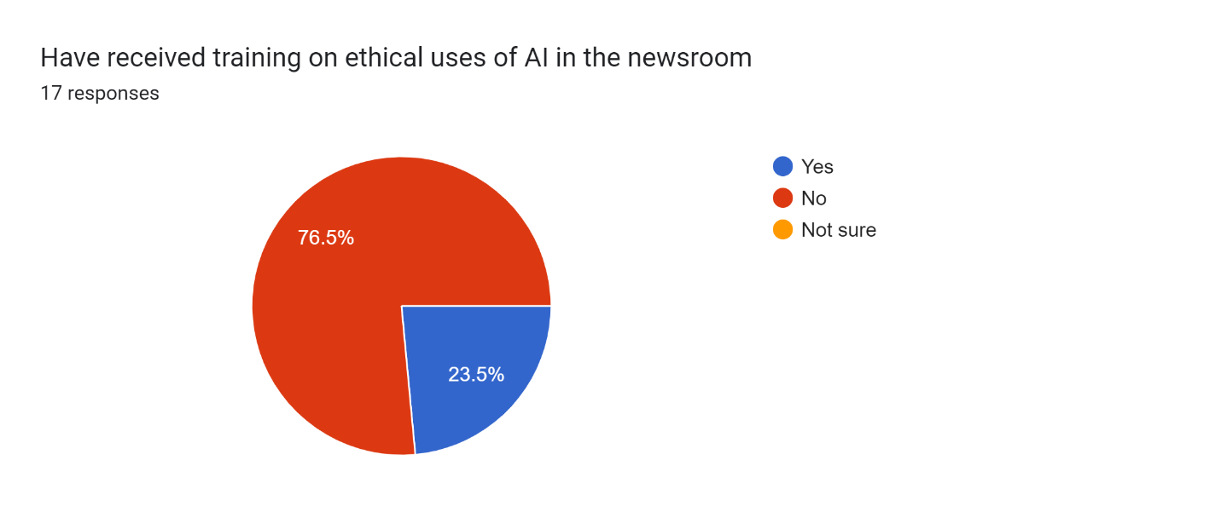

Despite the training that journalists have received on AI, with some led by MISA Zimbabwe, CITE, International Media Support and DW Akademie, the study found that more still needs to be done to improve AI skills competencies among journalists. 93.8% of the respondents expressed interest in being trained in AI (see Figure 13). Only 5% said they had already been exposed to training and hence didn’t see the need of repeating it. However, they pointed out that these training workshops should go beyond, appreciation of tools and security concerns to include policy issues, development of apps and newsroom guidelines for journalists. These training sessions should focus on the opportunities, risks and ethical implications of AI deployment and use in newsrooms and how to come up with acceptable use policies in newsrooms.

### **Figure 13: Relevance of training on ethical uses of AI in the newsroom**

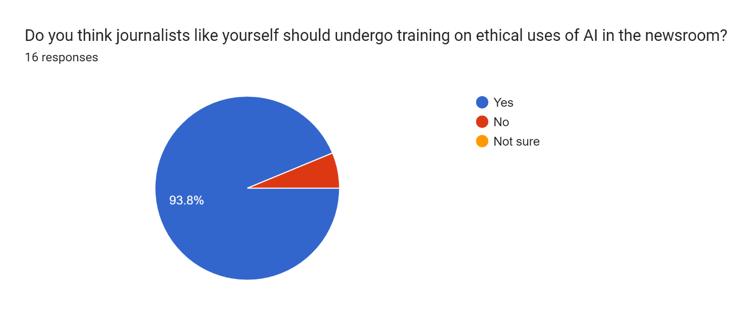

Journalists felt that training workshops on AI should focus more on humanising these tools, promoting safety and security and safeguarding law and copyrights. The online responses are captured below:

* How to use AI responsibly Al.
* The basics of ethics, what journalists should do and not do when using AI.
* The challenges of AI to real-life stories.
* The training should focus on how to use AI tools without breaching journalistic standards and how to be safe when using these tools.
* AI and ethical reporting.
* Issues around the law and ethics.
* laws and regulations regarding the use of AI for originality and ethical standards purposes.
* AI and ethical considerations.

Others emphasised the need to carry out periodic training programmes to ensure that journalists are kept abreast of developments in the industry.

Journalists must be constantly trained in how to recognize and deal with algorithm bias. There should be use of human judgement to assess the quality and relevance of news stories and journalists should be able to critically select sources and strive to promote diversity and inclusion even as they use AI in their reporting. Journalists can also advocate for greater transparency I how AI tools are used in news production to help identify and address biases. *(Interview with Kholwani Nyathi, November, 2024).*

Based on the data collected, no newsrooms currently have AI guidelines for AI use by journalists as indicated in Figure 14.

### **Figure 14: Existence of AI ethical guidelines and frameworks in Zimbabwean newsrooms**

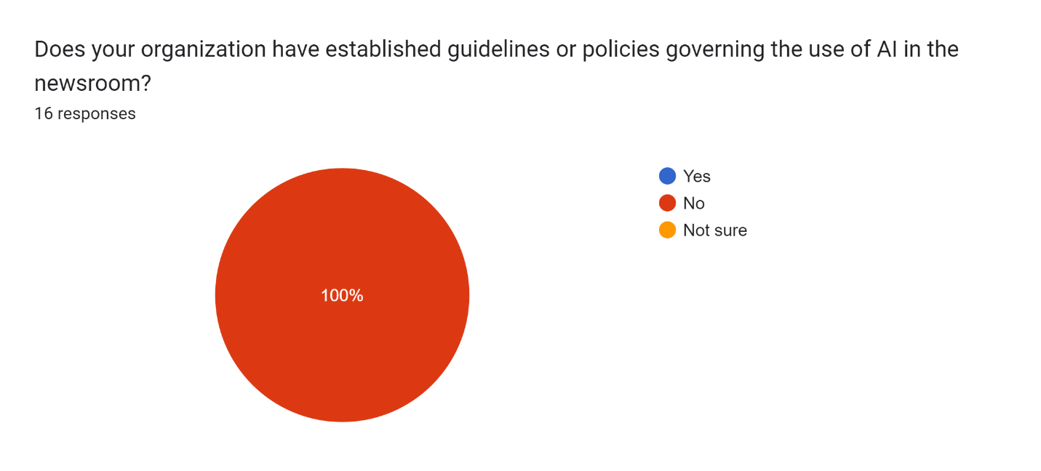

It is clear from the above figure that all Zimbabwean newsrooms have not yet established guidelines or policies on the use of AI. In this case, it means that journalists are using GenAI without any ethical guardrails. Figure 14 above clearly shows everyone who took part in the online survey concurred that their newsrooms have not yet put in places guidelines or policies to guide journalists on the ethical, secure and safe use and deployment of AI tools. In light of the above, there is an urgent need to review the code of ethics (illustrated in Figure 15 below) in tandem with changes in digital media ecosystem. The review process needs to take care of emerging ethical concerns as a result of AI. These include:

There should be standards for verifying AI-generated content, with clear human oversight mechanisms to prevent the spread of misinformation or fabricated stories. The code should include ethics around algorithmic accountability, ensuring that AI systems used in newsrooms are regularly audited for biases, fairness, and accuracy (*Interview Sean Ndlovu- CITE, October 2024*).

On the question of whether existing codes of ethics and conduct are sufficient to address AI-related issues, at least 75% of the online respondents said no. About 18,8% of the respondents were not sure (see Figure 15). Then at least 7,2% felt that existing codes of ethics and conduct were agile and adaptable to address emerging issues in the AI age.

### **Figure 15: Relevance of existing codes of ethics and conduct**

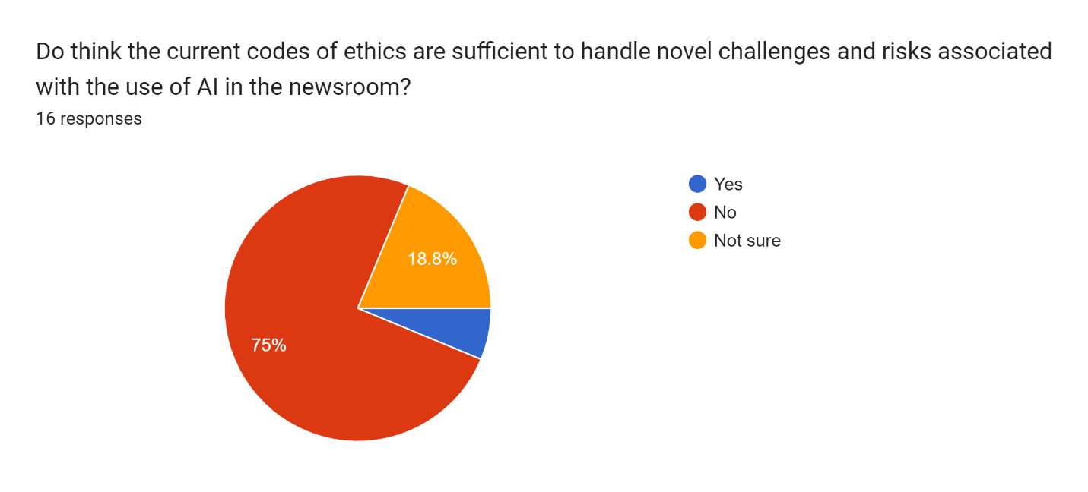

Evidence gathered in this study shows that there is a need for a code of ethics that addresses a wide range of issues. Some of the suggested areas that need intervention include:

* To what limit should journalists use AI in story writing.
* How to curb the breach of intellectual property and attribution of AI sources.
* Misrepresentation, misinformation and honesty.
* Ethics and transparency.

# **Necessity of government regulation in the design, use and deployment of AI**

Around the world, there are major debates about who should regulate the deployment of digital technologies and how. This problem is worse in countries that have poor digital and AI infrastructure. Respondents who were asked this question felt that the government must be a key player in the regulation of AI. However, there are concerns that because of the deep-seated mistrust of national governments in Africa, their involvement could endanger press freedom, freedom of expression, right to privacy, and other inalienable rights. Most preferred a multistakeholder approach involving designers, platform companies, civil society organisations, media organisations, regulatory bodies, and national governments. This chimes with Obia’s insightful observation that to successfully regulate general-purpose AI, the continent needs to canvass for a bold and inclusive approach to multistakeholder regulation, one that is a departure from the current practice of regulating social media by targeting internet users and the emerging practice of platform governance through co-regulation[29].

### **Figure 17: Necessity of government regulation around AI use**

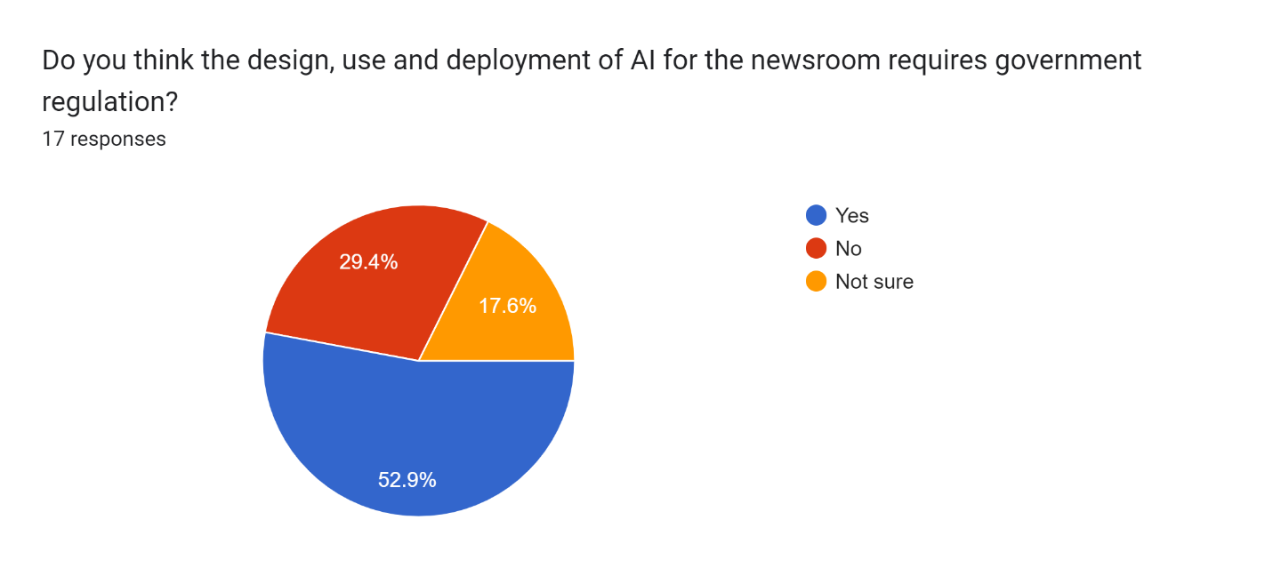

Regarding if the government is to be allowed to regulate AI issues in Zimbabwe, respondents said the policy should promote AI adoption but also deal with challenges that have emerged as a result of AI in the media. Online responses were as follows:

* It should protect newsrooms and manage citizen journalism on social media.
* Regulation of responsible use of AI.
* Law to make sure journalists abide by basic ethics.
* It should protect against AI abuse.
* It should include international best practices on AI.

Overall, journalists have limited knowledge of how to responsibly deploy AI tools for news gathering and reporting processes. Training that has been done has focused on appreciation more than the application of these tools in lived situations. As previous studies[30] indicate there is no consensus negative impact of AI on journalistic work. Some respondents felt that they had “limited knowledge of AI ethics” while others felt that AI “can disrupt journalists' work and remuneration”.

# **RECOMMENDATIONS**

* It is clear from the above findings that journalists are beginning to use AI without any ethical guidelines and frameworks. There is also a concerning trend around plagiarism, copyright violations and intellectual property rights. Given the findings this study makes the following recommendations: Newsrooms should invest in locally made and context-specific tools. They can also partner with donors, corporations and innovation hubs.
* Newsrooms should train journalists and editors on responsible uses of AI in the newsroom.
* There is a need for newsroom and sector-specific AI ethical guidelines and frameworks. The frameworks should clearly articulate acceptable and unacceptable design, deployment and use of AI in the newsroom.
* In crafting ethical guidelines, there is need to adopt bottom-up approaches by forming working groups to establish guidelines for Gen AI. These initiatives have the potential to promote ownership and adherence to these co-created documents.
* The Voluntary Media Council of Zimbabwe working in collaboration with the Zimbabwe Union of Journalists, Freelance Journalists Association of Zimbabwe, Zimbabwe Media Commission and the Zimbabwe National Editors Forum should revise the existing code of conduct for media practitioners to address AI-related ethical concerns. The revised code of conduct should prioritise human agency and oversight, privacy and governance, transparency, technical robustness and safety, diversity and non-discrimination, accountability and societal and environmental wellbeing (see Figure 18 below on Seven standards).
* Section on privacy in the existing code of ethics for media practitioners in Zimbabwe should take into account provisions from the Cyber and Data Protection Act.
* Because AI accentuated gendered disinformation campaigns against (especially female) journalists, there is need for that to be factored into the revised code of conduct and ethics.
* As part of the decolonization agenda, African-centred AI ethical guidelines and frameworks anchored in ubuntu, communitarianism and Afriethics need to be promoted.
* VMCZ should promote the adoption of ethical guidelines that promote a trustworthy AI system that is lawful (complying with all applicable laws and regulations), ethical (ensuring adherence to ethical principles and values) and robust (both from a technical and social perspective) to avoid causing unintentional harm.
* There is need for adoption of AI software and hardware systems in Zimbabwean newsrooms that are human-centric, i.e. developed, deployed and used in adherence to the key ethical requirements outlined below:

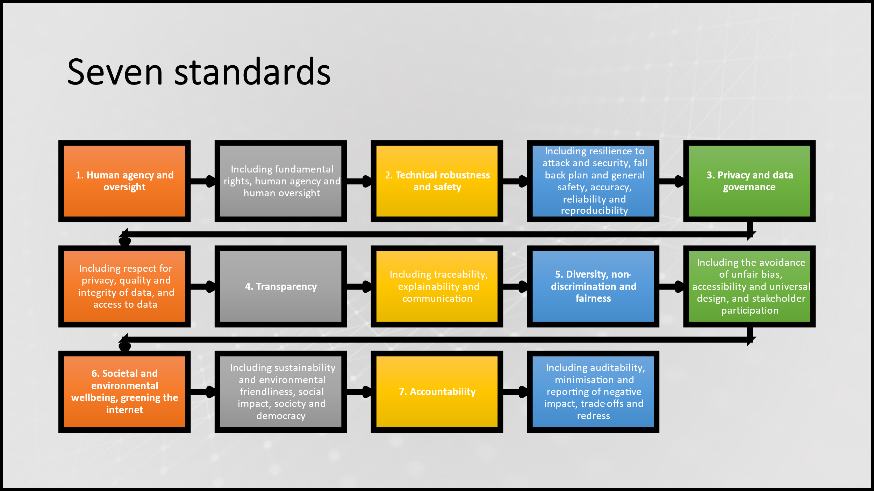

Source: European Parliamentary Research Service (2019)

While researchers concur, that AI brings many benefits, they also highlight a number of ethical and legal concerns, relating primarily to issues such as lack of human supervision, inaccurate information, privacy, lack of transparency, bias and plagiarism. For instance, AI poses risks to the right to personal data protection and privacy, and equally so a risk of discrimination when algorithms are used for purposes such as to profile people. These concerns are not unique to newsrooms in the Global North. It won’t be long before Zimbabwean newsrooms are dealing with these ethical considerations in their day-to-day operations.

# **CONCLUSION**

The report has found that journalists are already using GenAI tools for a wide range of purposes. It also revealed that some journalists are using AI tools involuntarily while others do not use AI tools in their work. There is evidence that the majority of journalists use Gen AI tools while others use a cross-section of tools. Other respondents indicated that there was no official position on how the tools were supposed to be deployed. The study also revealed that some journalists, as reflected in previous studies[31] use AI tools involuntarily (76.5%) while others (17.6%) do not use AI tools in their work. This shows that the majority of surveyed journalists are using Gen AI tools in their day-to-day news making practices. Only 5,9% of the surveyed journalists were uncertain about whether they were using GenAI or not. The majority of the respondents (70.6%) use text-based generative AI tools in their line of duty, followed by text-to-audio (11.8%). At least 5,9% of the respondents used transcription GenAI tools like Otter and Whisper. 5.9% used in-house tools while 5.9% deployed other AI tools on the market. Respondents had varied understandings of what constitutes artificial intelligence (AI). Other respondents raised concerns around the misuse of AI tools within newsrooms especially around plagiarism, undercutting the research culture and copyright violations. Some of the respondents felt that it was still early days to pass the verdict on its strengths and weaknesses. With regard to ethical challenges journalists faced by journalists in using AI in newsrooms, a mixed bag of results was found. Some of the participants felt that newsrooms in Zimbabwe not investing in acquiring the latest AI tools. Others felt that AI was not “authentic” or “original” because it is “artificial”. Its “artificialness” makes it prone to abuse, inaccuracies, biases and hallucinations. In terms of safety protocols that newsrooms have affected in their interaction with AI tools, the study found that the majority of respondents said they have not yet put in place any measures while some are experimenting with data encryption, anti-plagiarism check while others said they were not aware of any measures. Overall, results showed that newsrooms are ill-prepared for security breaches associated with the deployment and use of AI tools. The majority of respondents felt that using copy that has been produced by AI without acknowledging the source constitutes unethical journalistic conduct. The situation is made worse by the fact that most newsrooms in Zimbabwe have no AI ethical guidelines and frameworks. Respondents proposed many interventions to address ethical infractions associated with using AI tools in news production processes. The propositions ranged from radical stances, and capacity-building interventions to setting up journalistic guidelines on using AI. Overall, respondents felt that more training should be done to capacitate journalists and newsrooms should come up with AI guidelines for journalists. Journalists suggested that training workshops on AI should focus more on humanising these tools, promoting safety and security and safeguarding law and copyrights. Responses showed that there was still resistance among editors to publish AI-generated stories and failure to attribute at all. Due to a lack of clear guidelines, some journalists are resorting to using the tools without the knowledge of their superiors. As far as recommendations are concerned, journalists emphasised the urgent need to review the code of ethics in tandem with changes in digital journalism cultures, including automated journalism.

# **REFERENCES**

Centre for Intellectual Property and Information Technology Law (CIPIT), (2023). The State of AIi in Africa Report 2023. Strathmore University. Retrieved from https://cipit.strathmore.edu/state-of-artificial-intelligence-in-africa-2023-report/

Gwagwa, A., Kraemer-Mbula, E., Rizk, N., Rutenberg, I., & De Beer, J. (2020). Artificial intelligence (AI) deployments in Africa: Benefits, challenges and policy dimensions. The African Journal of Information and Communication (AJIC), 26, 1-28.

Hlongwane, J, Shava, G. N, Mangena, A, Muzari, T. (2024). Towards the Integration of Artificial Intelligence in Higher Education, Challenges and Opportunities: The African Context, a Case of Zimbabwe. [*International Journal of Research and Innovation in Social Science*](https://www.researchgate.net/journal/International-Journal-of-Research-and-Innovation-in-Social-Science-2454-6186?_tp=eyJjb250ZXh0Ijp7ImZpcnN0UGFnZSI6InB1YmxpY2F0aW9uIiwicGFnZSI6InB1YmxpY2F0aW9uIn19) 8:417-435.

Hokonya, S. (2024). Artificial Intelligence and Customer Experience: Key Takeouts from <https://data.misa.org/api/files/1710939061710g9luj26kj59.pdf>.

International Telecommunication Union (ITU). (2024). Solve the African language problem for inclusive AI development, (Online), Available at: https://www.itu.int/hub/2024/06/solve-the-african-language-problem-for-inclusive-ai-development/.

Katangamara, A. (2015) “The now, the future of AI”, Marketing Association of Zimbabwe. Retrieved from [Exploring the Impact of Artificial Intelligence on the Marketing Profession - Marketers Association Zimbabwe (maz.co.zw)](https://www.maz.co.zw/exploring-the-impact-of-artificial-intelligence-on-the-marketing-profession/)

Kothari and Cruikshank (2022); Gondwe (2023); Ogola., et al, ( 2023); Misa Zimbabwe (2023); Chiumbu & Munoriyarwa (2023).

Mabweazara, H. M. (2011a). “The Internet in the Print Newsroom: Trends, Practices and Emerging Cultures in Zimbabwe”. In *Making Online News: Newsroom Ethnographies in the Second Decade of Internet Journalism* edited by David Domingo and Chris Paterson, 57-69. New York: Peter Lang.

Mabweazara, H. M. (2011b). “ ‘Wiring African’ Newsrooms: The Internet and Mainstream Journalism Practice in Zimbabwe”. In *Cultural Identity and New Communication Technologies: Political, Ethnic and Ideological Implications*, edited by Wachanga, Ndirangu D, 144-162. Pennsylvania: IGI Global.

Mabweazara, H. M. (2011c). “Newsmaking Practices and Professionalism in the Zimbabwean Press.” *Journalism Practice*, 5(1): 100-117.

Mabweazara, H.. M. (2010). “‘New’ Technologies and Journalism Practice in Africa: Towards a Critical Sociological Approach”. In *The Citizen in Communication: Re-visiting Traditional, New and Community Media Practices in South Africa* edited by Nathalie Hyde-Clarke, 11-30. Cape Town: Juta & Co.

Mabweazara, Hayes M. (2013). “Normative Dilemmas and Issues for Zimbabwean Print Journalism in the ‘Information Society’ Era.” *Digital Journalism*, 1 (1): 135-151.

Mare, A. (2013). “A Complicated but Symbiotic Affair: The Relationship between Mainstream Media and Social Media in the Coverage of Social Protests in Southern Africa.” *Ecquid Novi: African Journalism Studies* 34 (1): 83–98.

Mare, A. 2014. New Media Technologies and Internal Newsroom Creativity in Mozambique, *Digital Journalism*, 2(1): 12-28.

MAZ Magazine. Available at: <https://www.maz.co.zw/wp-content/uploads/2021/06/ZimMarketer-December-Edition.pdf>. *Available at: h*[*ttps://www.chronicle.co.zw/president-to-launch-ai-media-c*](ttps://www.chronicle.co.zw/president-to-launch-ai-media-c)*ommunication-policies/#:~:text=President%20Mnangagwa%20is%20set%20to,Dr%20Jenfan%20Muswere%20has%20said.*

MISA (2023) AI Report on Southern Africa, Available at: https://misa.org/blog/now-available-ai-report-on-southern-africa/

Mokwetsi, J. (2014). Social media practice in Zimbabwe. *Rhodes Journalism Review*. (3): 34-37.

Munoriyarwa, A., Chiumbu, S., & Motsaathebe, G. (2021). Artificial Intelligence Practices in Everyday News Production: The Case of South Africa’s Mainstream Newsrooms. *Journalism Practice*, *17*(7), 1374–1392.

Mupfiga, P. S. & Fohlo, S. (2015). The Role of Artificial Intelligence and Expert Systems in the of Artificial Intelligence in Higher Education, Challenges and Opportunities: The African Context, a Case of Zimbabwe, *International Journal of Research and Innovation in Social Science,* Available at:[*https://www.researchgate.net/publication/382351580_Towards_the_Integration_of_Artificial_Intelligence_in_Higher_Education_Challenges_and_Opportunities_The_African_Context_a_Case_of_Zimbabwe*](https://www.researchgate.net/publication/382351580_Towards_the_Integration_of_Artificial_Intelligence_in_Higher_Education_Challenges_and_Opportunities_The_African_Context_a_Case_of_Zimbabwe)*.*

Ogola, G. et al (2023). AI, Journalism, and Public Interest Media in Africa. https://www.mediasupport.org/wp-content/uploads/2023/06/AI-Africa-Report-2023R-Double-Spread-View.pdf

Oxford Insights (2023) Government AI Readiness Index 2023, Available at:

Oxford Insights. (2023). <https://oxfordinsights.com/wp-content/uploads/2023/12/2023-Government-AI-Readiness->Index-1.pdf

Ruzvidzo, W. (2024). President to launch AI, communication policies, The Chronicle (Online), Sector, Available At: Https://Www.Researchgate.Net/Publication/353783428.

Shambira, L. (2020). Exploring the Adoption of Artificial Intelligence in The Zimbabwe Banking and Telecoms Sector in Zimbabwe, *Texila International Journal of Management,* Available at: <https://www.texilajournal.com/thumbs/article/Management_Vol%2010_Issue%201_Article_11.pdf>.

1. (Ogola., et al, 2023)
2. The ability of a digital computer or computer-controlled robot to perform tasks commonly associated with intelligent beings.  In other words, it denotes computer systems capable of performing complex tasks that historically only a human could do, such as reasoning, making decisions, or solving problems.
3. Generative AI is a type of artificial intelligence technology that can produce various types of content, including text, imagery, audio and synthetic data.
4. Mabweazara (2010); Mabweazara (2013); Mare (2014); Chari (2013)
5. Mlambo & Raftopolous (2010)
6. Mokwetsi (2014)
7. MISA Zimbabwe (2023)
8. Oxford Insights (2023:26)
9. Oxford Insights (2023:26)
10. MISA Zimbabwe (2023)
11. Ruzvidzo (2024)
12. Gwagwa, Kraemer-Mbula, Rizk, Rutenberg & De Beer (2020).
13. Kothari and Cruikshank (2022); Gondwe (2023); Ogola., et al, (2023); Misa Zimbabwe (2023).
14. Ogola, G. et al. (2023). 
15. Kothari and Cruikshank (2022); Ogola., et al. (2023); Gondwe (2023); Chiumbu and Munoriyarwa (2023); Misa Zimbabwe (2023).
16. Shambira (2020), Strathmore University (2023).
17. Kothari and Cruikshank (2022); Misa Zimbabwe (2023).
18. SANEF. (2024). The Media Discuss the Opportunities and Risks for Journalism in the Era of AI-driven Newsrooms. Retrieved from https://sanef.org.za/the-media-discuss-the-opportunities-and-risks-for-journalism-in-the-era-of-ai-driven-newsrooms/#:~:text=AI%20adoption%20in%20newsrooms%20ranges,use%20have%20often%20been%20overlooked.
19. Ogola et al (2023)
20. Ogola et al (2023)
21. Ogola et al (2023)
22. Ogola et al (2023)
23. Munoriyarwa,  Chiumbu, & Motsaathebe (2023).
24. Munoriyarwa et al (2023)
25. Munoriyarwa et al (2023)
26. Ogola., et al, (2023)
27. Gondwe, 2023; Ogola., et al, 2023.

    ### 

   
28. Ogola, G. et al (2023).
29. Obia, V. (2023). What can African countries do to regulate artificial intelligence? LSE Blogs. https://blogs.lse.ac.uk/medialse/2023/06/13/what-can-african-countries-do-to-regulate-artificial-intelligence/
30. Ogola et al. (2023)
31. Ogola., et al. (2023)